Assignment 3- Winter 2026
  - Deadline: 04/02/2026 @ 23:59
[Total Mark for this Assessment is 100]

Artificial Intelligence/ Advanced Artificial Intelligence
CSC-446-01 / CSC-546-01 / CSC-546-W1

Student Details:
Name: Bradley Moore  CRN: CSC 546 |  | ID: 35737785

Submission Instructions:
- This assignment must be submitted on Canvas pdf format only).
- The page number should appear on each page.
- All the text and diagrams must be electronically produced.
- Email submission will not be accepted.
- You are advised to make your work clear and well-presented; marks may be reduced for poor presentation. This includes filling your information on the cover page.
- You MUST show all your work, and text must not be converted into an image, unless specified otherwise by the question.
- The assignment proposal should contain the following sections:

Question one - [30 Marks]
- Color with red ONE correct answer (letter) for each of the following MCQs in the table below.

Actual Score

--

1 | 2 | 3 | 4 | 5 | 6 | 7 | 8 | 9 | 10
a | a | a | a | a | a | a | a | a | a
b | b | b | b | b | b | b | b | b | b
c | c | c | c | c | c | c | c | c | c
d | d | d | d | d | d | d | d | d | d

1. What is an AI agent protocol?
a. A training method for AI models
b. A standardized way for agents to communicate and coordinate
c. A database system
d. A hardware architecture
2. What is the main purpose of agent protocols?
a. Improve GPU performance
b. Enable interoperability between agents
c. Store data efficiently
d. Train models faster
3. Which of the following is a benefit of agent protocols?
a. Increased hardware cost
b. Reduced agent development complexity
c. Slower communication
d. Limited integration

4. Interoperability means:
a. Agents cannot communicate
b. Agents work only in one system
c. Agents can work together across different systems
d. Agents store data locally

5. Which protocol enables direct communication between agents?
a. MCP
b. ACP
c. A2A
d. AG-UI
6. The A2A protocol follows which model?
a. Peer-to-peer
b. Client-server
c. Centralized database
d. Blockchain
7. Which protocol uses REST API and HTTP?
a. ANP
b. ACP
c. MCP
d. Agora

8. Which protocol is designed for decentralized communication?
a. ACP
b. MCP
c. ANP
d. AG-UI
9. Which protocol connects agents to user interfaces?
a. MCP
b. AG-UI
c. A2A
d. ANP
10. What is the main role of MCP?
a. Connect agents to external services
b. Enable user interaction
c. Manage peer-to-peer communication
d. Train machine learning models

Question Two [30 Marks]

Provide an example of a multi-agent system that includes two or more agents using the MCP protocol, and illustrate their interactions by drawing a diagram that shows the communication flow between the agents.
Currently at work I am developing a multi agent system in which each agent monitors it’s own sharepoint list and responds to an orchestrator that directs the entire system. This model is very “Hub and Spoke” in a sense that I have to integrate all new bots for specific tasks into the system when something new is added. While this allows a lot of control over the system, it isn’t very dynamic and is difficult to scale.
With an MCP approach, all tools needed to complete any job are exposed to the multi agent system. Each scheduler bots (currently 6) can access the list in whatever fashion they deem is appropriate without specific prompt instructions to do so or guidance by the orchestrator. They can even use all tools necessary and can develop their own flows and coordination to complete tasks. It also allows for more creativity in a sense that the agents can do many more tasks without being specifically programmed for them. The entire system becomes much more fluid and agnostic and more of a architecture that can be integrated into other areas more smoothly without the need for specific tools and prompting.

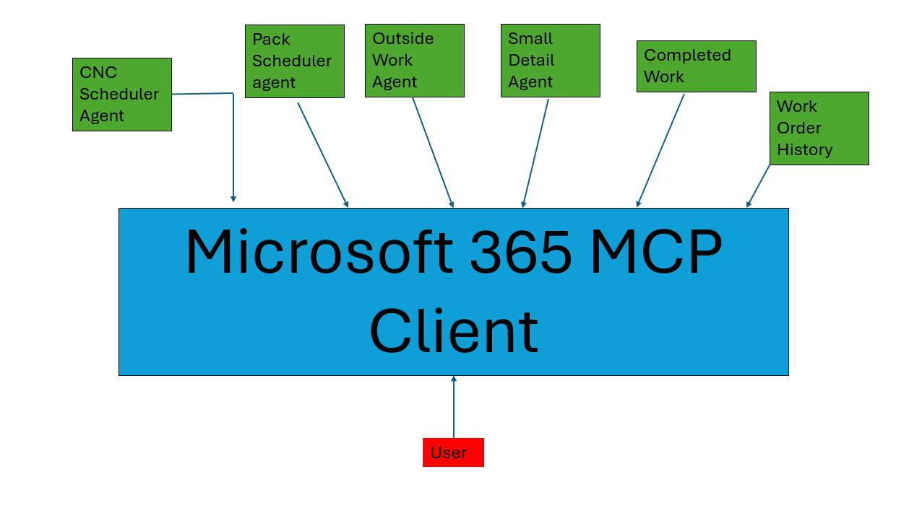

Question Three [40 Marks]
A company is developing a chatbot that interacts with users and learns from feedback to improve its responses over time. Based on this scenario, explain whether the chatbot can be considered an intelligent agent. Justify your answer.

I believe this does make the chatbot an intelligent agent. Intelligence to me is the ability to create a hypothesis, test it, and adjust based on results. In previous chatbots users would just receive predetermined responses based on the path their responses gave them. In this scenario, the chatbot behaves more with human intellect in a sense that it perceives it’s environment, develops actions in response to stimulus, measures the response to those actions, and generates a new response if appropriate. It can also be likened to the human brain in a sense that if a pathway is suboptimal or produces results that are poor, that neural pathway is changed to develop a more ideal solution. In the same token, if the neural pathway produced great results it will be reinforced, and also begin to influence pathways along the same lines around it. Also, the chatbot gets more attuned to it’s environment over time but if thrown into a different environment it will adapt to that as well.

